**Drag and Drop Rows**

This tip comes very handy when you are presenting a set of data in a GridView and want to rearrange rows at runtime. I am using the Table Drag and Drop Plugin for this example and it’s as simple as calling tableDnD() on the table. This plugin enables drag/drop on a table.

<head id="Head1" runat="server">

<title>Drag Drop Rows</title>

<script src="Scripts/jquery-1.3.min.js" type="text/javascript"></script>

<script src="Scripts/jquery.tablednd_0_5.js" type="text/javascript"></script>

<script type="text/javascript">

$(document).ready(function () {

$("#GridView1").tableDnD();

});

</script>

</head>

Before Drag

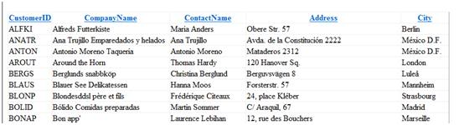

After Drop – deagging row with Customer ID ‘ANATR’ below ‘BLONP’

